Six sigma process improvement
- How we improve processes, not just how we design, manage and understand processes

Quality management recap
- Different definitions of quality, such as product-based definition, value for money approach, gap-based approach (expectations vs perceptions), fitness for use (conformance to expectations or specifications)
- Six Sigma today: defect is anything in the eyes of the customer whatever it might be
- Common cause vs special cause variation
- The earlier you catch a quality problem in your product the less it costs to resolve. This is where many companies don't do such a good job; you're trying to unpick what happened down the line

Today: how do we actually move forward – the world is dynamic our competitors are also trying to improve so how do we adopt a structured approach to continuous improvement.
- Tools for defining, measuring, analysing, improving and controlling quality improvements
  - DMAIC framework

Variation and process control
- Sample a process, plug those observations over time and we start to see variation. For example, a rice filling machine should always pour a kilogram.
  - There will be a level of variation around a mean
  - Factors that might explain this variation: worker error (lack of training or temp worker), the machine itself (degradation or poor maintenance), input materials (different type of rice from a different supplier), the method (loading the machine differently)
- How do we know if the variation is just random, and natural, or indicative of some assignable causes in the process.

Importance of variation
- Why do we worry about variation in OPS; variation is the enemy of efficiency and so you encounter time losses and also psychological losses. Variation, which can be driven by the working, the process, the materials or the method, comes in 3 forms:
  - Timing: process variation in process timing
  - Quantity: how much demand and when demand strikes a process
  - Quality: the yield rates
- If the rice filling machine had a wide level of variation around its mean, it's harder to detect whether the process is violating its control limits (the voice of the process). Not concerned with customer requirements
  - Becomes much more difficult to understand if this is just noise or is there actually an assignable cause that we need to investigate and fix
  - If you can compress the variation around that mean, then when there are changes, they’re much more easily noticeable both visually and statistically (on the control charts)
- Taguchi loss function is a graphical representation of how an increase in variation within specification limits exponentially increases consumer dissatisfaction. This contrasted to the American goal post philosophy of quality (Phil Crosby).
  - Linking to the Taguchi Loss Function, customers complain when they believe the package they receive differs from their expectations i.e. when there is variation.
    - Missing functionality
    - Faults and defects
    - Delivery delays
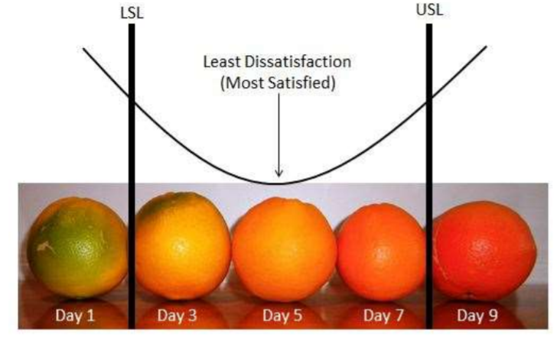
    - Asset reliability

- Domino's Pizza in Australia promised that you would get your pizza within half an hour or it was free, mean delivery was 23.5 mins. However, variation was wide; 25% of orders over 30 minutes. Flaw of averages: knowing the mean is insufficient, you've got to understand what the variation looks like.
  - Customers do not feel the average, they only care about their experience. If you have wide amount of variation, your customer experience is going to suffer those extremes, from super quick delivery to waiting forever
  - The point of Taguchi: you know the ideal situation is right on the mean, where customer is going to be most satisfied. As soon as you start to deviate, customer satisfaction starts to decrease. This decrease is a U-shaped relationship

Dabawalars of Mumbai
- Customers hate undesired variation. Desired variation delivers customer value, like accommodating service at the Ritz Carlton hotel, so we should build it in when they value it, but a lot of the time they don't understand variation.
  - This penalises us on an operations point of view and it also harms the experience of our customers.
- Six Sigma is the equivalent of 3.4 defects for every million opportunities that a defect could be created, incredibly high standard of performance
  - Dabawalars are an example of a poorly educated decentralised workforce working so perfectly in an unpredictable and challenging environment.
  - 1 error every 16m deliveries, better than six sigma

- Uses simple code. The workforce is largely uneducated, 3 main train routes with customers in hundreds of buildings spread throughout various floors of each building.
  - Simple visual controls: the 1 tells you what train route it needs to go on, the four numbers on the side one is the Dabbawalla who's going to look after that package, the S is a code for what building, then the last is the floor number and then for individual customers they give them different coloured bags and use the same bag every day.
- Dabbawallas always concentrate on the same area so they have the same customers every day and they know the coloured bags helps them recognise which Tiffin box needs to go to which customer.
  - Qatar business class focus on flight number and what time you need to be at the gate – minimising the info for customer to remember reduces variation and errors

Process capability and control

Statistical Process Control Chart
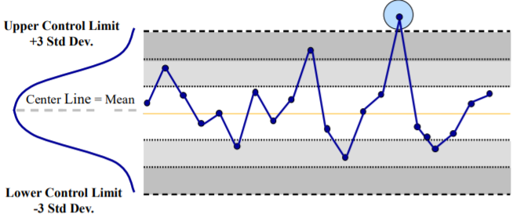
- Understanding the normal distribution which describes random variation when the process is operating normally (in control) then we can use this distribution to draw control limits
- Common cause variation is the variation which occurs within these control limits. Special or assignable causes of variation are the specific patterns or points outside of the control limits

Process capability
- Defined as the match between the Upper and Lower Control Limits with the Specification limits.
  - Specification limits are determined by the customer (voice of the customer)
  - Every process has variation; plus or minus 3 sigma are natural tolerances (voice of the process).
    - Sigma = standard deviation, measure of the distribution’s spread
- Capability = $\frac{Specificaion range}{Natural process variation (6σ)}$
  - Capability = $\frac{USL-LSL}{6σ}$
  - Process is capable is Cp > 1
- Therefore capability is achieved by increasing the specification range or by reducing variation i.e. sigma.
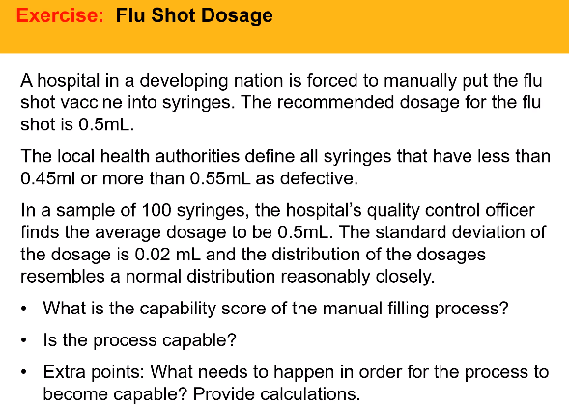
Capability is the ability of the process to produce customer requirements i.e. specification range divided by natural process variation.

- Cp exists where USL – LSL / 6s > 1
- Capability = 0.83; (0.55-0.45) / 6 x 0.02 = 0.83
- 0.83 <1, so the process is not capable. We either need to increase range or decrease standard deviation to achieve capability.
  - Customers do not easily relax expectations, and can’t where there is regulation
  - Standard deviation needs to be reduced to 0.16 to make the process capable.
- Statistical control is not a natural state, but is achieved by eliminating special variation. Only once the process is in control can we see its natural variation and capability
  - Special cause variation will have a different distribution around the mean, maybe skewed as opposed to normally distributed
- When a process is capable, it produces output that meets customer specifications. When it is capable AND in control, it consistently produces output that meets customer specifications.

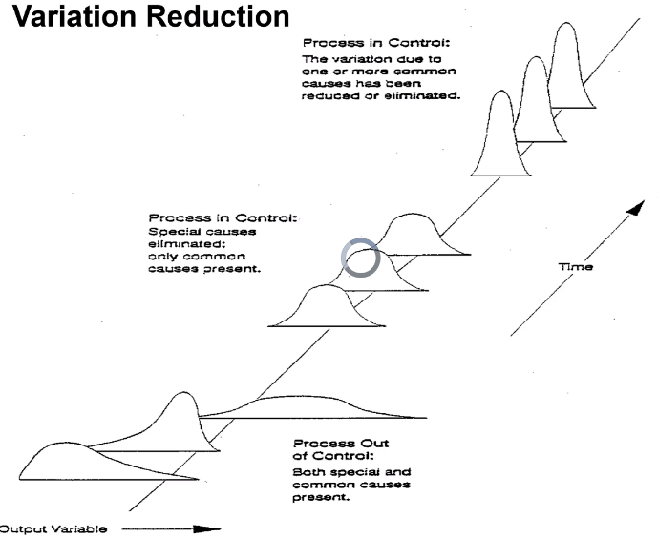
Variation reduction
- Assess capability
- Control the process (eliminate special cause variation)
- Eliminate common cause variation

- Are control charts useful in sectors which desire variation or subject service delivery? Control charts come from manufacturing, in services where standardisation is important the same principles apply (control centres create control charts)

Six Sigma

Introduction
- Six sigma aims to define the causes of defects, measure these causes, and analyse them so they can be reduced
  - The focus for eliminating defects in the process is to reduce variation
  - Emphasises the roles of individuals e.g. training, and belt systems
- Six sigma is customer focused; a defect is defined as anything outside of customer specifications
- The target is 3.4 defects per million opportunities in customer output
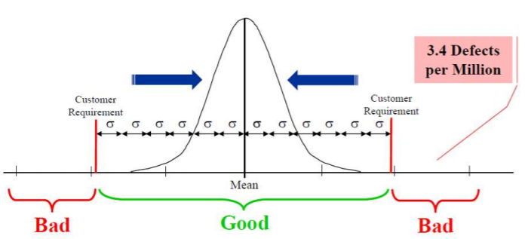
  - Opportunity is defined as a chance for a defect to occur. Opportunities are independent of each other.
- Reducing variation reduces the size of sigma, or standard deviations about the mean. This increases the allowable variation still within customer specifications, when measured in sigma. The idea is the process can tolerate + or – 6 standard deviations variation whilst still satisfying customer requirements
  - 3 sigma = 67,000 defects per million
  - 6 sigma = 3.4 defects per million
- Deviation of six sigma required for a defect (which is output outside specifications)

- In the 1980s, we wanted to know why Japanese firms were so much better at quality – striving for zero defects (TQM) rather than having an acceptable level of defects. However backsliding can occur (initial jump in improvement, plateau then backslides downwards). Need constant pressure, its like pushing a cart up a hill
  - Management might stop monitoring, people might regress to their old ways during stressful times or new workers and supervisors
  - Idea with 6 sigma is to try and push the level of performance higher again, building upon the backslide of TQM
  - Motorola came up with it – statistical process control on steroids, wrapped in a process control methodology
- Define defects in the eyes of customer, use data to measure these defects and analyse them so they an be reduced. Defects reduced by reducing variation (probability of a customer experiencing a defect), and is applied in manufacturing and services.
  - Use teams (different coloured belt) to emphasise training level in six sigma.
  - Lean is about reducing lead times by reducing waste. Subtly different focus; six sigma is about how the work should be done, not about is this work which adds value to customer
6 sigma is about understanding the customer – their requirements affect the amount of opportunities for a defect
- Article couches 6 sigma as a business strategy, a way of running your business (not rlly)
- 6 sigma as a process improvement methodology (our focus).
- Is a process sigma, akin to process capability (how robust is our process as a statistical figure). Dabbawala example

How is 6 Sigma achieved? DMAIC Framework
- Define: who is the customer and what is important to them, thus what process needs improvement. What is the goal of this improvement (same as CPQ)?
- Measure the existing process using data collection to understand how process performance is measured
  - Important to measure the things that matter to customers, and on the same axes that customers measure these variables on
  - Important that our measurement is consistent to allow analysis
- Analyse the system to identify the factors causing the effects, and their root causes.
  - Need to fix the cause, not just symptoms. 7 tools to do so:
  - Fishbone diagram (cause and effect), control charts, Pareto charts, run charts, scatter plots, histograms, the 5 whys
- Improve the process by eliminating the root cause.
  - A good solution should eliminate the root cause in a cost-effective way, with minimum negative impact on any other part of the system
  - Solutions can employ Poka-Yoke or fail-safing
    - Nozzle does not fit diesel vs petrol
    - Different colour baby hats show how to engage in a service
- Control the newly improved process to avoid backsliding and the loss of gains
  - Set up processes to measure ongoing performance over time
  - Use checklists and standardised forms to increase visibility of performance to supervisors

DMAIC Cycle
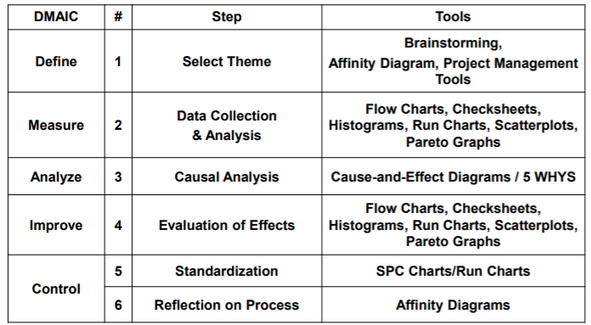

Takeaways
- Six sigma: just be aware of what it is and what the basic ideas are. Learn about lean and value, as well as affinity diagrams.
- Quality needs to be managed as a system (Deming). Management is responsible for the existence and elimination of causes of variation.
  - Workers empowered to identify and eliminate the causes of variation
- When a process is capable and in control, it is consistently producing output that meets customer needs
- 6 sigma focuses on reduces defects by reducing variation
  - Quality tools used to understand process variation and its causes

Understanding six Sigma requires providing a conceptual definition and identifying underlying theory. Our research argues that although the tools and techniques in six Sigma are similar to prior approaches to quality management, it provides an organisational structure not previously seen. This structure helps organisations more rigorously control process improvements activities at the same time creating a context that enables problem exploration between disparate organisational members

Further reading

Essential Six Sigma (Lucas, 2002)
- Methodology for disciplined quality improvement (six sigma) are coupled with the current business system to achieve total quality management
  - Current system + Six sigma = TQM
- Uses a modified Shewhart cycle (plan-do-check-act) with the goal of near elimination of defects from any process product or service
  - Using defects per million opportunities (DPMO) is useful as it is an easily understood metric that handles variables and attributes critical to quality (CTQ).
  - The identification of CTQ variables is the first step of six sigma.
- Improvement project (using DMAIC) must be integrated with the overall goals of the organisation. Top level support are important aspects of integration.
  - Rolls out not according to a vague notion of improving everything, but divides quality into comprehensive dimensions and compartments and focuses on improving these.
- Six sigma implementation is top-down, with executive management providing a Champion for each project, who provides necessary resources and breaks down organisational barriers to ensure the project is a success.
  - Champion’s bonus typically tied to project success (40% at General Electric)
  - Champion is a black belt and project members are green belts
  - One black belt per 100 employees and 1 master black belt per 10 black belts is optimum

Definition and underlying theory (Schroeder, 2007)
- Six sigma allows the organisation to act more organically in coming up with new improvement ideas and operate more mechanically when implementing them. This paper answers:
  - The base definition for 6 sigma and possible variants
  - Theoretical basis underlying six sigma
  - New developments in six sigma theory
- Motorola originally developed Six Sigma in 1987 ( Folaron, 2003). In 1994, CEO of Allied Signal introduced Six Sigma as a business initiative to “produce high‐level results, improve work processes, expand all employees’ skills and change the culture” (ASQ, 2002). This was followed by the implementation of Six Sigma at General Electric in 1995 (Slater, 1999).

Defining Six Sigma
- Various definitions currently proposed by literature:
  - “high‐performance, data‐driven approach to analysing the root causes of business problems and solving them” (Blakeslee, 1999, p. 78).
  - “business process that allows companies to drastically improve their bottom line by designing and monitoring everyday business activities in ways that minimize waste and resources while increasing customer satisfaction” (Harry, 2000)
  - Disciplined and statistically based approach for improving product and process quality (Hahn, 2000)
- Authors used case studies of manufacturing and service companies.
- “What's different about six sigma is you’re taking people out of their full‐time jobs … we’re teaching them how to solve a problem using statistics and methods. And then they’re [Black Belts] assigned to work with a Champion, who understands what's really impacting the business and will pick a tough problem for that Black Belt to work on”.
  - Executives viewed Six Sigma in very broad terms as an approach to running a business that leads to competitive advantage.
- A black belt emphasizes the idea of getting to the root cause of problems in order to improve a process. This is very important because there is a tendency to jump to conclusions and to attack symptoms rather than the underlying problems in business.
- Authors suggest that “Six Sigma is an organized, parallel‐meso structure to reduce variation in organizational processes by using improvement specialists, a structured method, and performance metrics with the aim of achieving strategic objectives.”

Breaking down the definition
- Parallel means exists outside an organisation is normal way of operating. Meso means the structure integrates both micro and macro levels. Six Sigma is a combination of macro-organisational strategy and micro tactics (Barney, 2002).
- Firms use full-time improvement specialists called Black Belts who go through 4 weeks of Six Sigma training. Black Belts are selected based on technical and leadership skills, as their role is to bridge the gap between management and project improvement teams
- Structured method for process improvement, both firms used the DMAIC method. Both had strong emphasis on using this method systematically to find the root cause of the problem.
  - Standard quality tools employed such as cause-effect charts, statistical process control.
  - These tools use the 7 classic tools of quality control and 7 new tools for problem formulation and diagnosis (Gitlow, 1995; Mizuno, 1988)
  - DMAIC involves different organisational members at different steps e.g. champions are most active in the define step, process owners are most active in the control step, green belts are active in the measure, analyse and improve steps, and black belts are active in all steps of the process
    - Prior approaches to quality management have not given this much role clarity to organizational members in each step of the method.
- Companies used a variety of special metrics, both customer-orientated and financial metrics. The measurement orientation and focus on metrics promotes “fact-based” decision-making, with dialog based on expertise and facts rather than positional authority or domination (Eisenhardt, 1997). This allows more effective identification of the “root cause. Further, basing goals on six sigma metrics resulting in specific, challenging goals which increase performance relative to vague, non-quantitative goals (Locke, 1990). Clear goals also create team alignment and provide a basis for feedback (Ivancevich, 1982).
  - Fundamental aspect of six sigma is the identification of critical-to-quality characteristics that are vital to customer satisfaction (Evans, 2005)
  - Desired process sigma measure levels are defined relative to customer requirements, which therefore establish project improvement goals (Linderman, 2003)
  - One company included a financial analyst on Six Sigma teams, who “translates what the team does into dollars and cents” (Smith, 2002). The analyst will also track benefits for a year after the project to ensure the benefits are realised, linking to the control aspect of DMAIC.

Theoretical foundation of six sigma
- Organisations characterised into mechanistic structures (high levels of standardisation, formalisation, specialisation, hierarchical) and organic structures (low levels). Contingency theory is that organisations are more effective when their structure fits their primary task (Donaldson, 2001). However, some argue for “dual structures” from which organisations can achieve both efficiency and adaptability (Duncan, 1976). Six sigma achieves this organisational ambidexterity (Tushman, 1996), mixing control and exploration.
  - Structural control (Eisenhardt, 1985) through goals and metrics, metaroutine and decision rights allocation
  - Structural exploration through multi-functional teams leading to boundary spanning (Schwab, 1985) and communication (Hill, 1995) using common language.
- Structural control is achieved through control strategies focused on outcome, behavioural and social controls.
  - Outcome control specifies outcomes of tasks (Nidumolu, 2003) which requires the use of measurable metrics (Eisenhardt, 1985) based on customer requirements, DPMOs and process sigma measures (Linerman, 2003).
  - Behavioural control regulates activities by clarifying specific behaviour required in task execution. DMAIC provides a routine that workers follow to improve processes.
    - Structured method avoids jumping to conclusions and ensures an adequate search for alternative solutions to the problem.
    - Champions ensure proper execution by conducting reviews at each step.
    - Strategic process selection allocates decision rights to different members in the improvement process
- Structural exploration helps teams be flexible regarding new and different perspectives. Boundary spanning roles bridge functional areas (GE’s Work-Out program; Ulrich, 2002) and break down barriers preventing problem understanding (Daft, 2001).
  - Institutionalizing Six Sigma creates a common language and method for solving problems. This common language helps overcome barriers created by diverse interpretive schemes e.g., both an analyst and engineer know what process sigma is

Discriminating Six Sigma from TQM
- Six sigma’s focus on financial and business results is to some extent unique. Six sigma requires financial returns from most projects thus the financial focus is at the project level, as opposed to the organisational level in TQM.
  - Aggressive insistence on financial return from improvement projects is largely new
  - Six sigma also recognises that not all projects produce short-term financial returns, so projects with strategic value are still undertaken (Pande, 2000)
- Using a structured method for process improvements is not distinctive. However, the degree of insistence on the structured methods the intense training of full-time specialists (Snee, 2003) and the full integration of statistical tools are unique.
- Use of specific metrics, gauging DPMO, CTQ and process sigma, is new. Stretch goals motivate creative thinking (Breyfogle, 1999) and ensure a customer focus
- Use of full-time improvement specialists is new. Previously organisations were reluctant to invest in full time specialists and often assigned improvement tasks to already overworked staff on a part time basis.
  - In 1997 General Electric invested $250m in training nearly 4000 black belts and 60,000 green belts (Haryy, 2000). This added $300m to net income in 1997 alone

Chakravorty (2010) – where process-improvement projects go wrong
https://www.wsj.com/articles/SB10001424052748703298004574457471313938130
- Process improvement programmes like Six Sigma can see participants lose motivation and fall back into old habits.
  - Six sigma aims to tackle production defects, and lean manufacturing aims to remove waste which doesn’t add value
  - However 60% of Six Sigma initiatives fail
- Programmes fail due to the stress-strain curve – as stress increases over time, the programmes stretch, yield and then fail.

Stretching phase
- People find themselves stretching, and are willing to tackle all necessary tasks in the early going. This results in strong performance gains.

Yielding phase
- In the middle stage of an improvement project, when the Six Sigma “champion” moves on, implementation starts to wobble, and teams may struggle to maintain their earlier gains.
- Teams can lose their objective voice, also the person who performed sophisticated stat analysis which allowed them to prioritise the tasks affecting performance most.
  - Some team members may also begin pushing their own agendas
  - Teams can get bogged down with stat analysis, or spending too much time on the improvement project and therefore miss production quotas
- Amidst pressure to keep up day-to-day duties they may revert to old habits (same as a fat person stopping the gym when work demands heat up). Performance gains falter.
  - Six sigma champion has bonus linked to success of initiatives, so is incentivised to highlight the projects showing progress and ignoring the faltering ones.

Failing stage
- Teams are unable or unwilling to do improvement tasks, effort collapses. Improvement expert long gone, no additional training, team members are discouraged by failures to build on initial success. They stop caring (also as its not tied to their performance reviews).
- Teams report achievements incorrectly, giving false sense of success. Took several months before VP became aware of widespread failures (as champion hid them)

Lessons learned
- Extended involvement is required to maintain motivation and gains. If cost of a full-time improvement expert is too high, assign part-time one to multiple teams in an extended role. Then train managers to take the role
- Performance appraisals should be tied to successful improvements. Without incentives employees often regress to old habits after initial enthusiasm dies down.
- Improvement teams should have no more than 9 members, and timeline for launching a project should be no longer than 8 weeks.
  - Bigger team = greater chance members will have competing interests, big problem especially when improvement expert moves on
  - Longer it takes to implement improvements, greater the chance people and resources will be diverted to other efforts.
- Executives should participate directly in projects – avoids them relying on someone else’s interpretation of success, e.g. the champion / director who may create illusion of success.

Making process improvements stick (2018)
- Holweg and Upton: improvement initiatives (lean, six sigma, agile) create initial benefits in efficiency and costs, but the gains often fade quickly. Important to make the programmes stick, as well as putting them in place.
  - Examined 204 lean projects which were focused on processes that could benefit from fewer steps, to increase labour productivity
  - Only 79% showed initial improvements, and after two years only 44% were still producing results above the baseline
  - After two years only 36% were showing continuous improvement, a key goal of many lean projects
- Researchers focused on factors already identified as influencing the initial success of lean projects – experience of leaders, level of training and team familiarity with each other. None explained the regression.
  - Implication is that factors accounting for initial success is different to what’s needed to hold on to gains or improve further. Interview lean champions said these help:
  - Visible support from board members – without it workers doubt conviction and backsliding ensues. Projects with strong support had 35% greater improvement after a year and were less likely to backslide.
  - Consistent measurement and monitoring; problems arise when early improvements hit diminishing returns.
  - Aligning the programme to the organisation’s purpose, and communicating this to workers. Get workers invested in the project, taking ownership of it.
  - Direct efforts in ways which will help employees, e.g. by targeting pain points – hospital initiative aiming to decrease time spent on paperwork
- Key obstacle to sustained improvement is initiative fatigue, which happens when leaders jump quickly from one fad to another.

Making your service fail-safe (Chase, 1994)
- Poka-yoke fail-safe is a concept of TQM which prevents human errors becoming defects in the end products – this can also be applied to services.
  - The actions of the system, the server and the customer can be fail-safed
  - Poka-yokes are either warnings that signal the existence of a problem or controls that stop production until the problem is resolved
- Shingo classifies his poka-yokes by 3 different methods of detecting errors:
  - Contact methods rely on the part’s physical dimensions
  - Fixed value methods signal that some known quantity of components is not available or has not been used
  - Motion-stop methods require some error-prone step be completed before an obvious step is performed.

Fail-safing services
- Service fail-safing must account for customer’s activities as well as the producers. Customer errors can directly affect the service outcome.
  - Dead man’s lever on power mowers is a poka-yoke done for liability reasons
- Many services evolve through multiple interactions at different locations, so fail-safe methods must be set up for interactions conducted directly.
  - Area where the customer and system interaction is the critical area (the front office)

Fail-safing the server
- Task poka-yokes deal with work service functions performed away from the customer e.g. repairs, and prevented work being done incorrectly, too slowly or not requested.
  - E.g. computer prompts to aid technological discussions, microphones to ensure servers and customers voices are audible, appropriate weighing and measuring tools (McDonald’s French-fry scoops)
- Treatment poka-yokes prevent errors in the contact between the server and the customer, such as a lack of professional behaviour e.g. not noticing or listening to the customer
  - E.g. signals like eye contact, bell on shop door
- Tangible poka-yokes prevent errors in the physical elements of the service, such as dirty waiting rooms, incorrect bills and so in.
  - These errors are caused by failures to clean facilities, provide clean uniforms, control noise, smell, light and temperature

Fail-safing the customer
- Preparation Poka-Yokes seek to ensure customers bring the necessary materials, understand their role and engage the correct service.
- Encounter Poka-Yokes seek to reduce customer errors during the encounter, which can be due to inattention, misunderstanding or memory lapses.
  - Prevented by ensuring customers remember steps in the service process, follow system flow, specify desires sufficiently and follow instructions.
  - Warning and controlling customer actions – airline toilet doors must be locked to turn the lights on, employees wearing symbols that alter customer’s expectations (trainee)
- Resolution Poka-Yokes

